

Software Development High Level Design
LDAP Web Service

Version 1.0
Created: February 29, 2007

Contributors
Thomas B. Holland
Table of Contents
1.0 Summary 4
2.0 Business Requirements 4
3.0 Understanding of System Requirements 4
4.0 Design and Resolution 5
Data Conversion: 7

1.0 Summary

2.0 Business Requirements

O’Charley’s internal applications group has defined Active Directory as being the security mechanism for role based privileges inside internally developed applications. User’s need to be able to be looked up in the directory both for group membership and authentication.

3.0 Understanding of System Requirements

There needs to be a common framework for accessing Active Directory. This will solve a few fundamental issues.

- It will normalize the way in which users are authenticated against the ldap server
- It will significantly cut down on the amount of code which needs to be written

The framework should be application agnostic and globally accessible from both Windows Forms and Web Applications. The client consuming the platform should be agnostic of any AD configuration settings as the framework should handle all of this. Authentication and searching should be done simply by instantiating and object and calling the appropriate method.

4.0 Design and Resolution
.NET Web Services provide a way to expose objects and methods across that network that can be used by any type of client with an active network connection, regardless of the platform used on that client.

Impacted Program:

- Functionality to be added 1
- New Web Service To Be Created

Process flow Diagram (EXAMPLE)

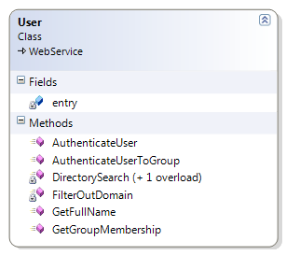

Public Methods

- AuthenticateUser
A method which takes in a user’s username and password and returns a Boolean value if they can be authenticated to AD.

- AuthenticateUserToGroup
A method which takes in a user’s username and a group name, and returns a Boolean value which determines if that user is a member of the specified group.

- GetFullName
A method which takes in a user’s username and returns their Full Name (or “cn”).

- GetGroupMembership
A method which takes in a user’s username and returns a generic list of all of the security groups that they are a member of.

Private Methods

- DirectorySearch (1 overload)
A private overloaded method which takes in a username and property, or username, password and property and searches the directory based on the property given.

- FilterOutDomain
A method which takes in a username, and strips the domain off of it. This allows for users to enter either domain\username or just username.

Controls:
Only the public methods are consumable, and thus the code and underlying data is controlled by the class and method modifiers.

Data Conversion:
n/a

